**UBUNTU COMMANDS :**

**1) PWD :**

(Present working directory) - it shows present directory you are there.



**2)ls :**

- list all the folders in the current directory.



**3)ls –l :**

- list all the folders of current directory in a descripted format with folder creation date,time,total folders etc.

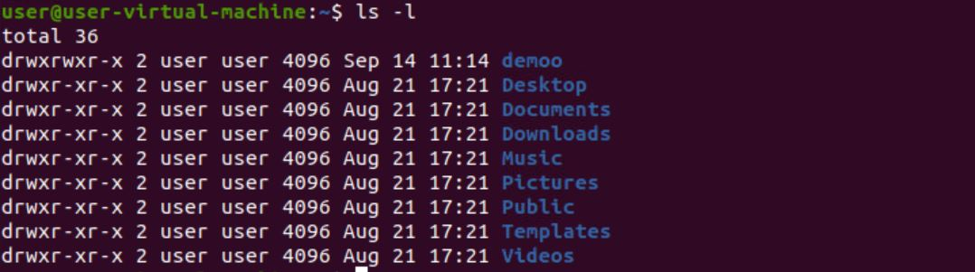

**4)ls –a :**

- to list the hidden folders list.

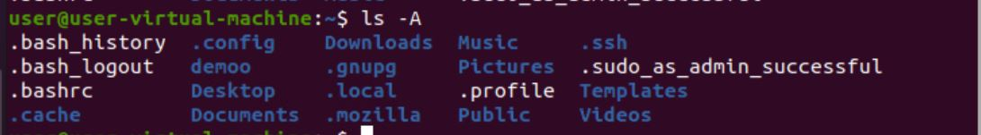

**5) ls –A :**

- ignore the two type . and .. hidden files and show the rest of the files.



**6)ls –f :**

-it shows the list of files in an unordered format.

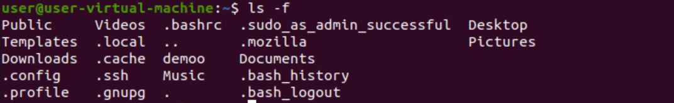

**7) mkdir :**

- This command is used to create a new directory

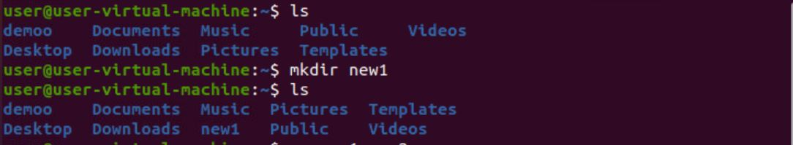

**8) mv :**

- This command is used to rename a directory.

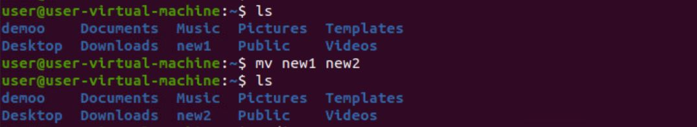

**9) rmdir :**

- This command is used to delete a directory.

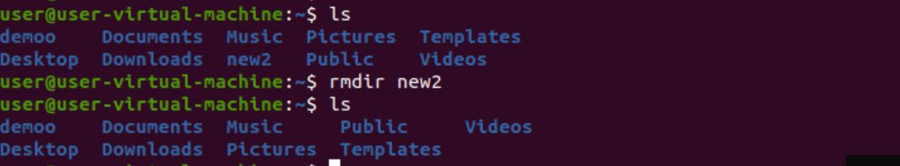

**10)echo :**

- This command is used to print a text on the terminal screen.



**11) clear :**

- This command is used to clear the old commands output from the terminal screen.

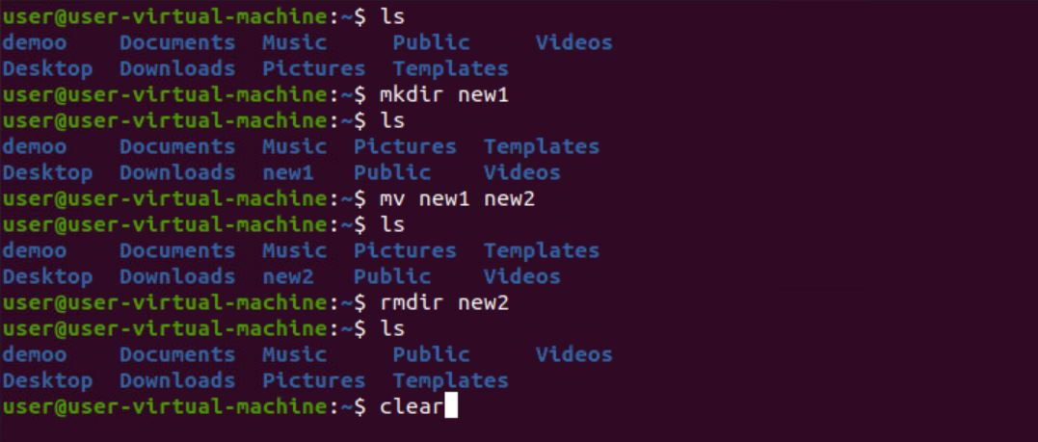

-The above image is before using the clear command

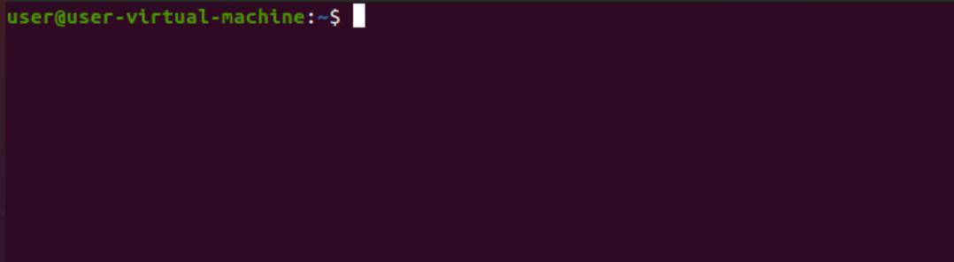

-The above image is after using the clear command

**12)cd <folder name> :**

- This command is used to enter into a folder.



**13)cd .. :**

- This command is used to go back to a folder which is before the current folder.



**14)cd :**

- This command is used to go back to the current directory directly from any folder of the current directory.



**15)cd / :**

- This command is used to go to the root (/) directory.



**16)man**(manual) **:**

**-** manual of a command is shown using this command.



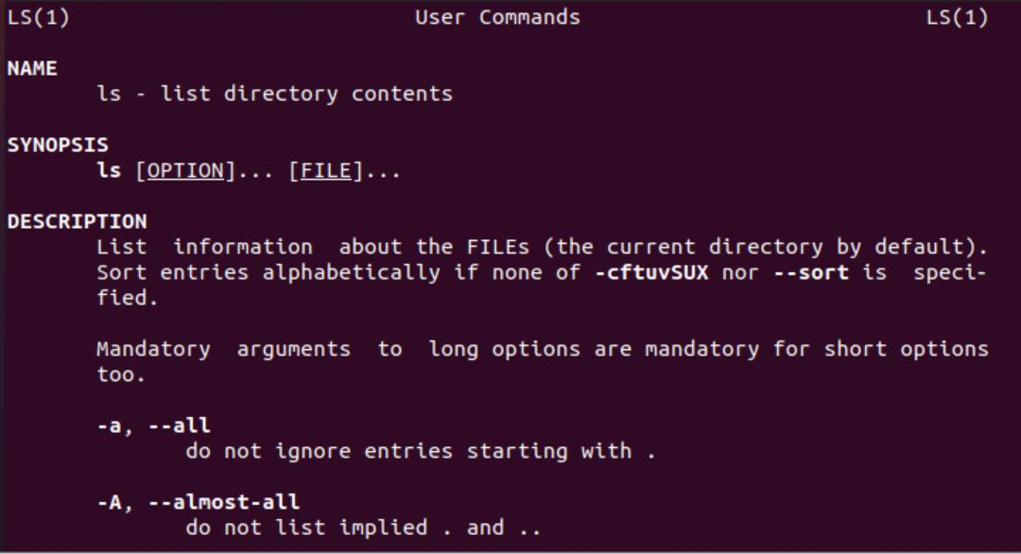

**17)exit :**

**-** This command is used to close the terminal.



**18)who :**

- This command is used to get the user login details like date,time and name.



**19)touch :**

- This command is used it is used to create a new file

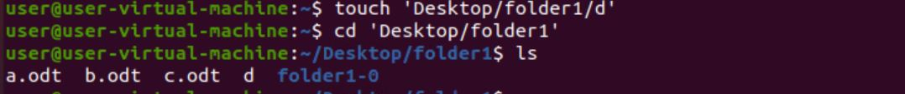

**20)rm :**

- This command is used to delete a file

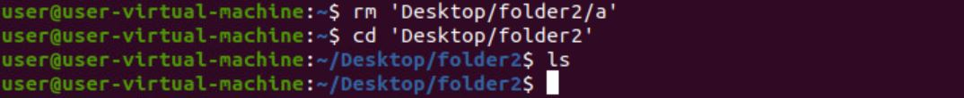

**21)cp :**

- This command is used to copy the content of the file

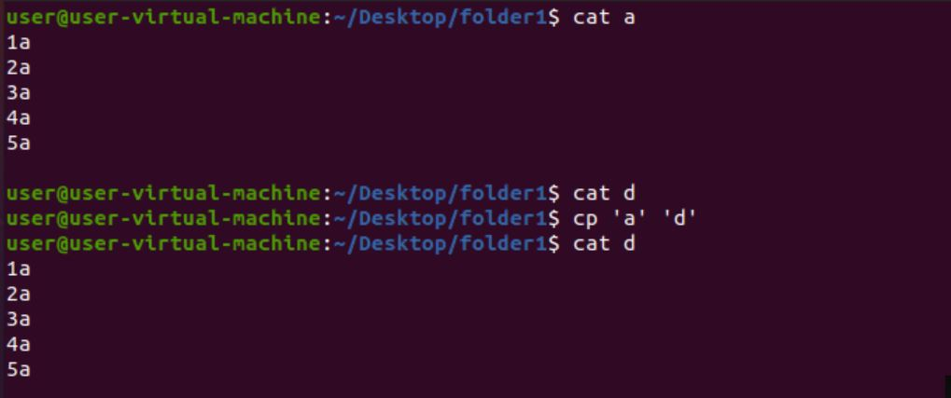

**22) mv :**

- This command is used for moving the file from one folder to another folder.



**23)cat :**

- This command is used to display the files in a folder or content in the files.

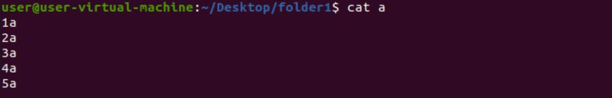

**24)tac :**

- This command is used to show the filecontent in a reverse format.

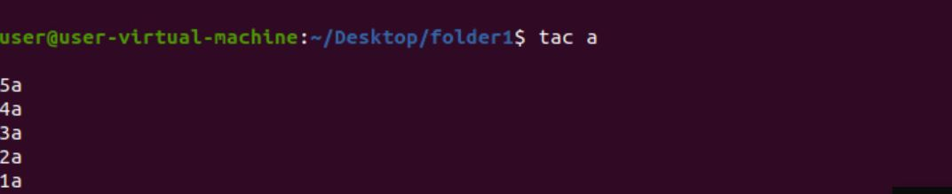

**25) cat filename1 filename2 filenam3 :**

- This command is used to show multiple file contents at same time.

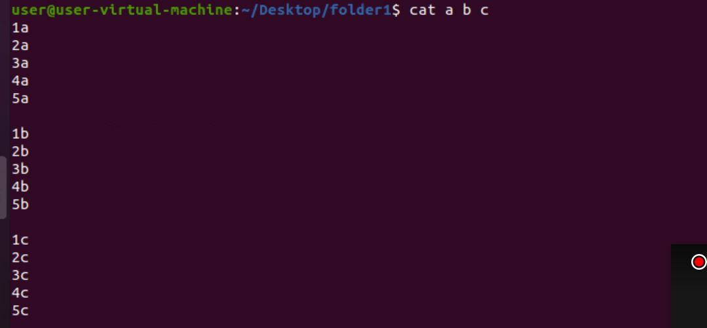

**26)sort :**

- This command is used to sort the content in the file

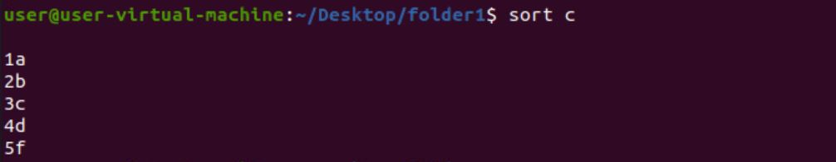

**27)cat –filename1 filename2 :**

- This command is used to show the content along with its line numbers.

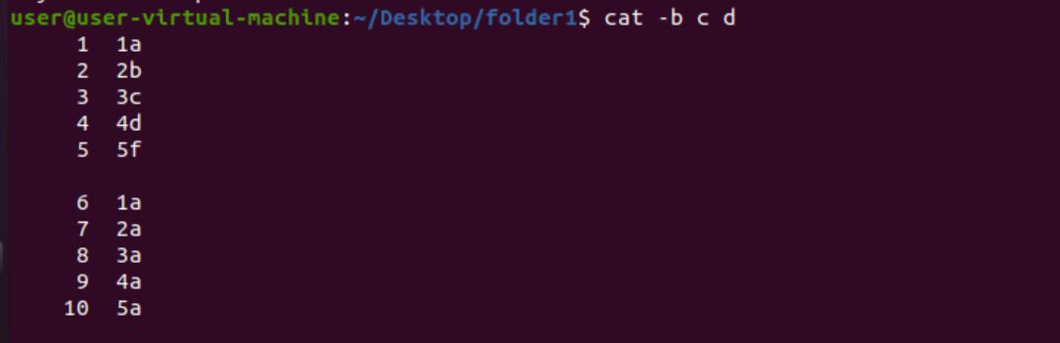

**28)date :**

- This command is used to display the date.



**29)cal :**

-This command is used to display the calendar.

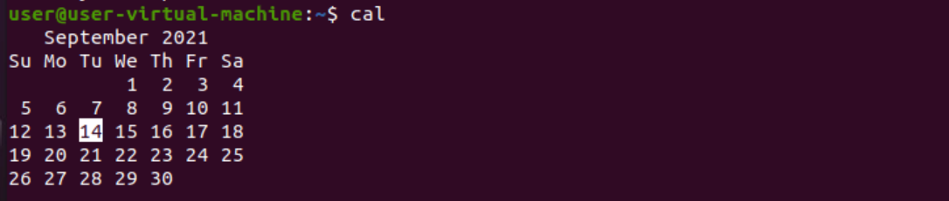

**30)mkdir -p folder1/folder2/folder3 :**

- it will make many folders as 123 4 inside one another

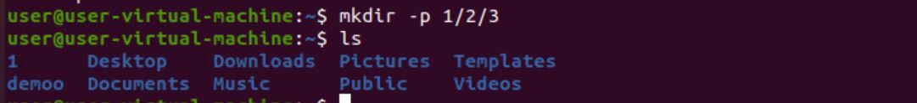

**31)mkdir-p demo{folde1,folder2,folder3} :**

- it will create folder as demo1,demo2,demo3.

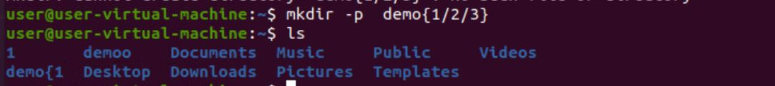

**32)rm -rf 1 :**

- it will delete all the folders inside the1 along with1

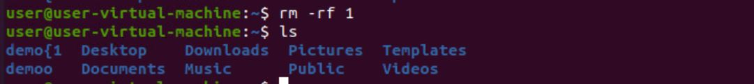

**33)passwd :**

- This command is used to change the password of the current user.

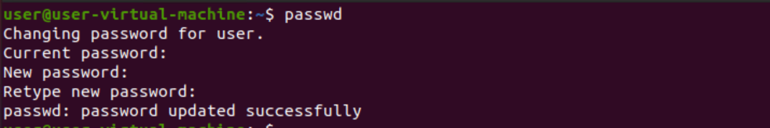

**34)tree :**

- This command is used to show the files in a hierarchy manner.

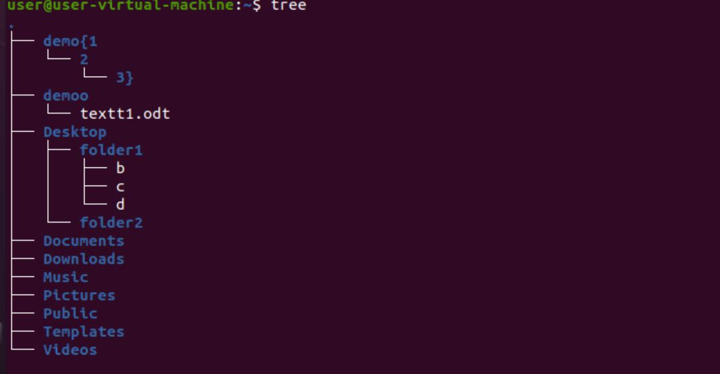

**35)command --help :**

- This command is used to show us the particular command.

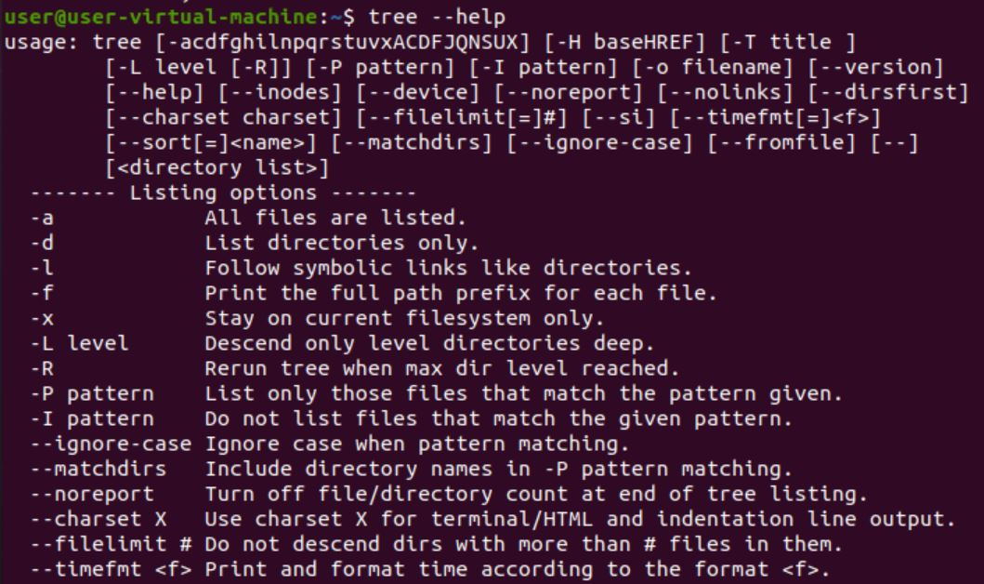

**36) ls –lr :**

- This command is used to show the directories in a recursive manner.

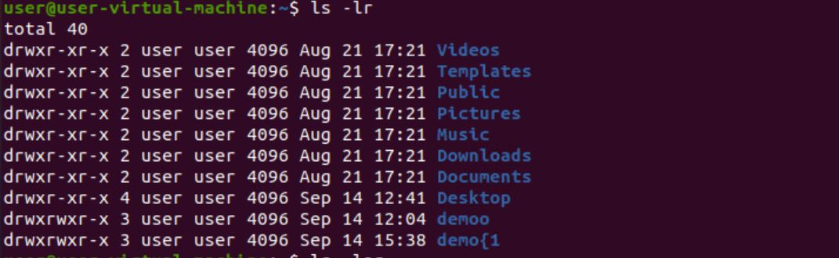

**37)ls –lar :**

- This command is used to show the directories in a reverse manner.

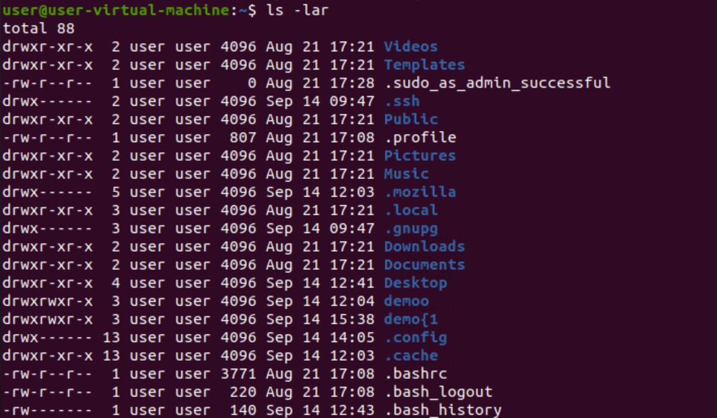

**38)tree –c:**

-the command is used to show the directories and files in a tree hierarchy manner.

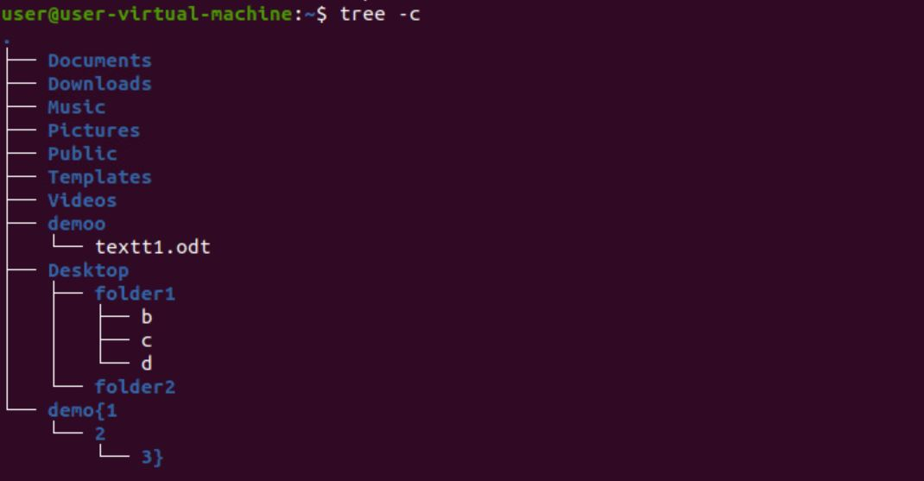

**39)tree –cd** :

- -the command is used to show only the directories in a tree hierarchy manner.

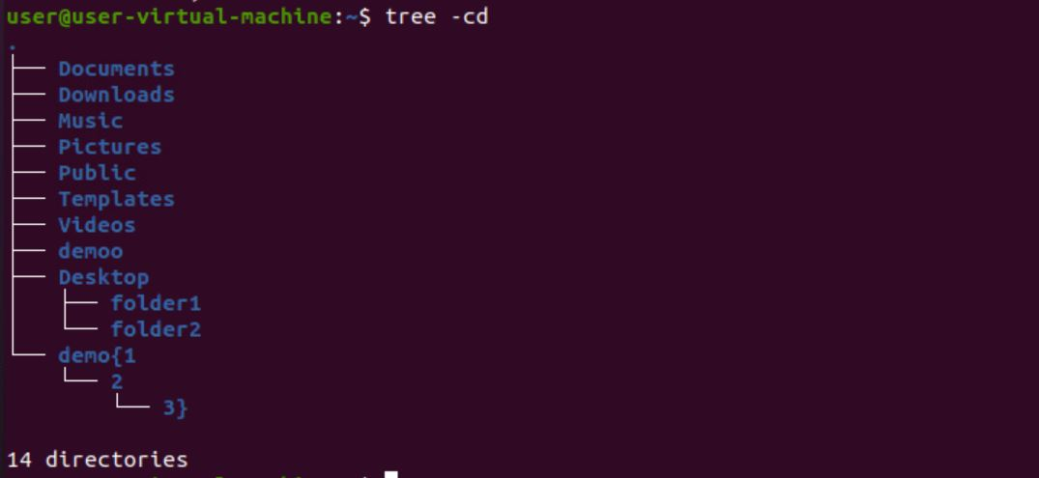

**40)tree –d :**

-this command is used to display only the directories from new to old

